# Department of Computing

**SE-312: Software Construction**

**Class: BESE 9AB**

# Lab 06: Styling in React

**Date:**

**Time: Monday, 09:00am-12:00pm & 02:00-05:00pm**

# Instructor: Dr. Seema Jehan

**Lab Engineer: Mr. Aftab Farooq**

# Muhammad Asim Khaskheli

# BESE-9A

**250319**

**Deployed at :** [**http://lab6-asim.surge.sh/**](http://lab6-asim.surge.sh/)

**GitHub Repo:** [**https://github.com/Asim-2000/Software-Construction-Labs/tree/main/lab6**](https://github.com/Asim-2000/Software-Construction-Labs/tree/main/lab6)

# 

# Lab 06: Styling in React

**Introduction**

React is a JavaScript library created by Facebook. React is a tool for building UI components. React creates a VIRTUAL DOM in memory.

**Objectives**

The objective of this lab is using the styling concepts of react to design a simple react web page. The students will design a simple website. Students will explore different styling components.

**Tools/Software Requirement**

NPM, Node.js, React, HTML, CSS

**Previous Knowledge:**

HTML, CSS, Javascript (ES6).

**Helping Material:**

W3Schools: <https://www.w3schools.com/react/default.asp>

Material UI: <https://material-ui.com/>

**Note:**

* You can use “<https://material-ui.com/>” to design different components for your webpage such as appbar for navigation bar and cards in what we do section.
* Be creative in your design and explore different styling components.
* To use the above website, follow these steps:

1. Install Material-UI's source files via npm. We take care of injecting the CSS needed.

**$ npm install @material-ui/core**

1. Load the default Roboto font.

**<link rel="stylesheet" href="https://fonts.googleapis.com/css?family=Roboto:300,400,500,700&display=swap" />**

1. Here is an example how to use these components. Material-UI components work without any additional setup, and don't pollute the global scope.

**import React from 'react';**

**import { Button } from '@material-ui/core';**

**function App() {**

**return <Button color="primary">Hello World</Button>;}**

**Lab Tasks:**

**Task 1:** Design a simple web page using React. You can use components from “<https://material-ui.com/>”

1. Make a simple web page using react.
2. Set the background of your choice
3. Add a name and logo of your choice on the top left corner
4. Make a top navigation bar on the upper right corner and add 3-4 components (No need to make pages for components, just make a navigation bar)
5. Make an introduction section and add a heading, some text and a picture on the page as shown in the ss

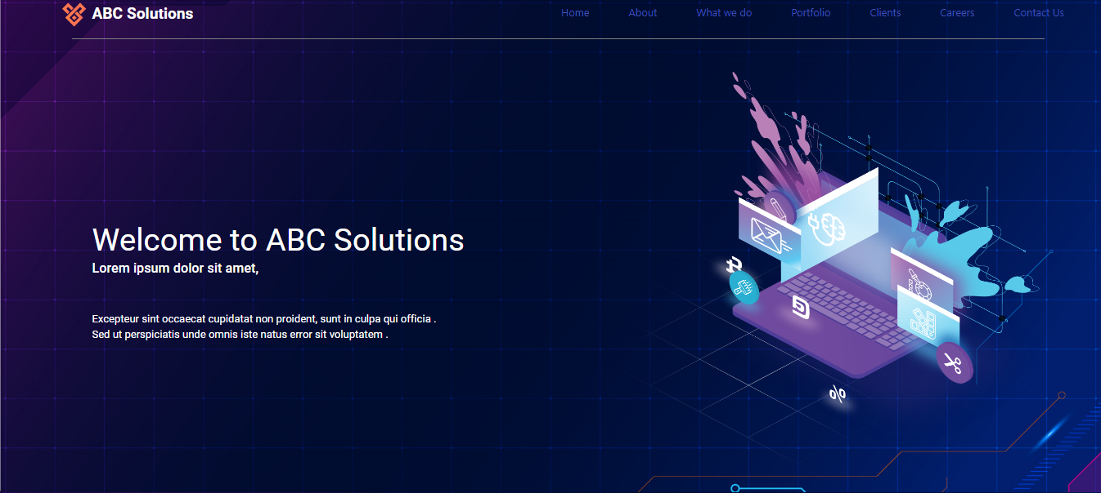

**Task 2:**

1. Continue the task 1 and add an about us section below the introduction section.
2. Add a picture, heading and some text in this section as shown in the ss.



**Task 3:**

1. Continue the above tasks and make another section named “what we do”.
2. Add a heading some text in this section.
3. Insert at least 3 different cards using “<https://material-ui.com/>”.
4. Add some text on the cards.
5. Join all three sections.

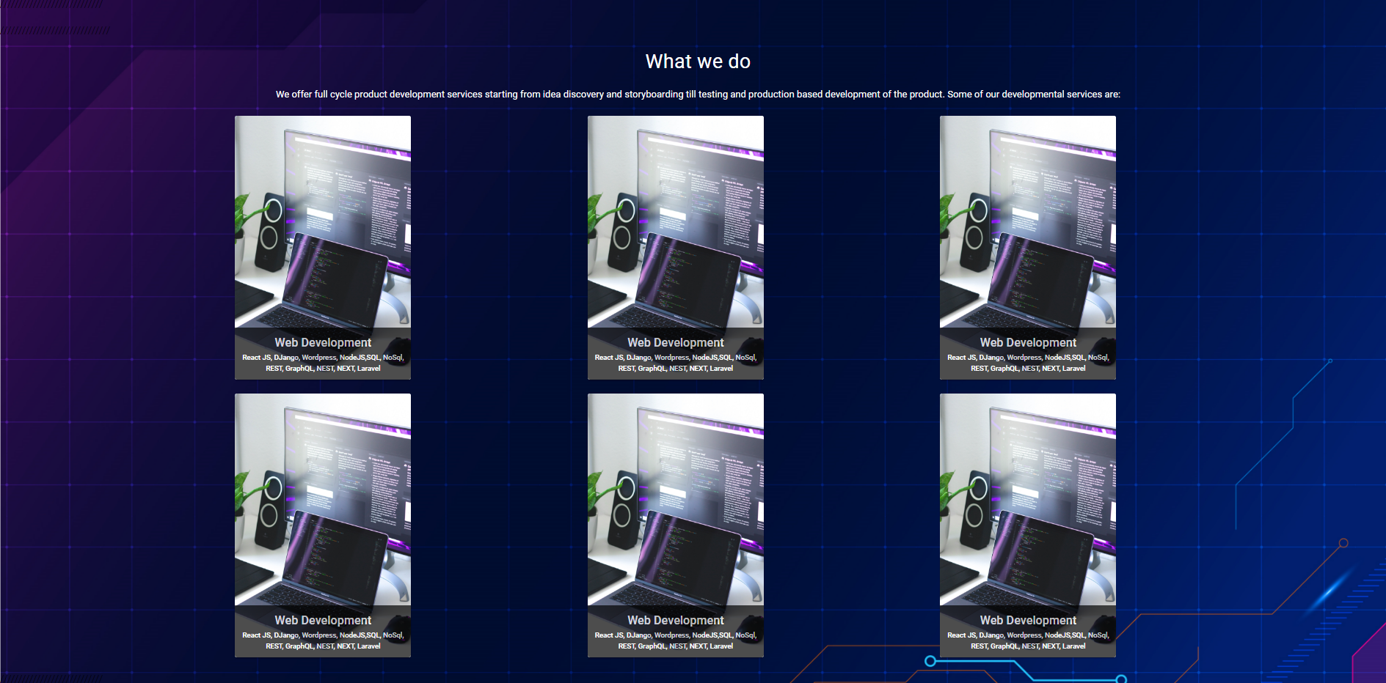

|  |
| --- |
| Solution |
| Task 1 Code:  Deployed at : <http://lab6-asim.surge.sh/>  GitHub Repo: <https://github.com/Asim-2000/Software-Construction-Labs/tree/main/lab6>  Navbar.js  import React from 'react';  import { makeStyles } from '@material-ui/core/styles';  import Toolbar from '@material-ui/core/Toolbar';  import Typography from '@material-ui/core/Typography';  import Button from '@material-ui/core/Button';  import AppBar from '@material-ui/core/AppBar';  const useStyles = makeStyles((*theme*) => ({    root: {      flexGrow: 1,    },    menuButton: {      marginRight: *theme*.spacing(2),    },    title: {      flexGrow: 3    },  }));  export default function ButtonAppBar() {    const classes = useStyles();    return (      <div *className*={classes.root}>        <*AppBar* *style*={{ background: "#2E3B55" }} *position*="static">          <*Toolbar* *style*={{ 'paddingLeft': '0px' }}>            <img *style*={{ 'width': '105px', 'backgroundColor': 'white' }} *src*="images/logo2.jpg" *alt*={'Hello'}></img>              <*Typography* *style*={{'color': 'black', 'maxWidth': '330px','marginRight':'60%', 'border': '1px solid black', 'borderLeftStyle': 'none', 'borderRadius': '0px 10px 10px 0px', 'backgroundColor':'white', 'paddingLeft':'60px'}}  *variant*="h6" *className*={classes.title}>              DevCreatives            </*Typography*>            <*Button* *color*="inherit">Menu</*Button*>            <*Button* *href*='#aboutus' *color*="inherit">About Us</*Button*>            <*Button* *href*='#whatwedo' *color*="inherit">Our Work</*Button*>          </*Toolbar*>        </*AppBar*>      </div>    );  }  Task Output Screenshot:    Task 2 Code:  NavBar.js  import React from 'react';  import { makeStyles } from '@material-ui/core/styles';  import Paper from '@material-ui/core/Paper';  import Grid from '@material-ui/core/Grid';  const useStyles = makeStyles((*theme*) => ({    root: {      flexGrow: 1,      margin:'auto 100px'    },    paper: {      textAlign: 'center',      backgroundColor: 'orange',      marginTop: '1%',      color: 'white'    },  }));  export default function CenteredGrid() {    const classes = useStyles();    return (      <div *className*={classes.root}>        <*Grid* *container* *spacing*={1}>          <*Grid* *item* *xs*={3}>            <img  *style*={{ width: "200px", paddingTop: "5px" }}  *src*="images/logo2.jpg"  *alt*={"Hello"}            ></img>          </*Grid*>          <*Grid* *item* *xs*={9}>            <*Paper* *style*={{ paddingTop: "1px" }} *className*={classes.paper}>              Lorem Ipsum is simply dummy text of the printing and typesetting              industry. Lorem Ipsum has been the industry's standard dummy text              ever since the 1500s, when an unknown printer took a galley of type              and scrambled it to make a type specimen book. It has survived not              only five centuries, but also the leap into electronic typesetting,              remaining essentially unchanged. It was popularised in the 1960s              with the release of Letraset sheets containing Lorem Ipsum passages,              and more recently with desktop publishing software like Aldus              PageMaker including versions of Lorem Ipsum.            </*Paper*>          </*Grid*>        </*Grid*>      </div>    );  }  Task Output Screenshot:    Task 3 Code:  Card.js  import React from 'react';  import Card from '@material-ui/core/Card';  import { makeStyles } from '@material-ui/core/styles';  import CardContent from '@material-ui/core/CardContent';  import Typography from '@material-ui/core/Typography';  const useStyles = makeStyles({    title: {      textAlign: 'right',      fontSize: 14,    },    pos: {      textAlign: 'right',      marginBottom: 12,    },    bullet: {      display: 'inline-block',      transform: 'scale(0.8)',      margin: '0 2px',    },    root: {      width: 500,      borderTop:'none',      borderRadius: '0px 0px 30px 30px',      backgroundColor: 'orange',      margin: '0px auto',    },  });  export default function SimpleCard() {    const classes = useStyles();    return (      <*Card* *className*={classes.root}>        <*CardContent*>          <*Typography* *className*={classes.title} *color*="textSecondary" *gutterBottom*>          <h2 *style*={{'textAlign':'center', 'color':'white'}}>Welcome to Creatives Club</h2>          </*Typography*>        </*CardContent*>      </*Card*>    );  }  ItemCard.js  import React from 'react';  import clsx from 'clsx';  import { makeStyles } from '@material-ui/core/styles';  import IconButton from '@material-ui/core/IconButton';  import Typography from '@material-ui/core/Typography';  import Card from '@material-ui/core/Card';  import Avatar from '@material-ui/core/Avatar';  import { red } from '@material-ui/core/colors';  import FavoriteIcon from '@material-ui/icons/Favorite';  import CardHeader from '@material-ui/core/CardHeader';  import ShareIcon from '@material-ui/icons/Share';  import ExpandMoreIcon from '@material-ui/icons/ExpandMore';  import MoreVertIcon from '@material-ui/icons/MoreVert';  import CardMedia from '@material-ui/core/CardMedia';  import CardContent from '@material-ui/core/CardContent';  import CardActions from '@material-ui/core/CardActions';  import Collapse from '@material-ui/core/Collapse';  const useStyles = makeStyles((*theme*) => ({    root: {      maxWidth: 345    },    media: {      height: 250,      paddingTop: '56.25%',    },    expand: {      transform: 'rotate(0deg)',      marginLeft: 'auto',      transition: *theme*.transitions.create('transform', {        duration: *theme*.transitions.duration.shortest,      }),    },    expandOpen: {      transform: 'rotate(180deg)',    },    avatar: {      backgroundColor: red[500],    },  }));  const RecipeReviewCard = (*props*) => {    // console.log(props)    const classes = useStyles();    const [expanded, setExpanded] = *React*.useState(false);    const handleExpandClick = () => {      setExpanded(!expanded);    };    return (      <*Card* *className*={classes.root}>        <*CardHeader*  *avatar*={            <*Avatar* *aria-label*="recipe" *className*={classes.avatar}>              {props.attr.name[0]}            </*Avatar*>          }  *action*={            <*IconButton* *aria-label*="settings">              <*MoreVertIcon* />            </*IconButton*>          }  *title*={props.attr.name}  *subheader*={"last updated on " + props.attr.lastUpdated}        />        <*CardMedia*  *className*={classes.media}  *image*={props.attr.link}  *title*="MMM"        />        <*CardContent*>          <*Typography* *style*={{ 'height':'120px' }} *variant*="body2" *color*="textSecondary" *component*="p">          {props.attr.desc}          </*Typography*>        </*CardContent*>        <*CardActions* *disableSpacing*>          <*IconButton* *aria-label*="add to favorites">            <*FavoriteIcon* />          </*IconButton*>          <*IconButton* *aria-label*="share">            <*ShareIcon* />          </*IconButton*>          <*IconButton*  *className*={clsx(classes.expand, {              [classes.expandOpen]: expanded,            })}  *onClick*={handleExpandClick}  *aria-expanded*={expanded}  *aria-label*="show more"          >            <*ExpandMoreIcon* />          </*IconButton*>        </*CardActions*>        <*Collapse* *in*={expanded} *timeout*="auto" *unmountOnExit*>          <*CardContent*>            <*Typography* *paragraph*>              {props.attr.moreInfo}            </*Typography*>          </*CardContent*>        </*Collapse*>      </*Card*>    );  }  export default RecipeReviewCard;  Whatwedo.js  import React, { useState } from 'react';  import Grid from '@material-ui/core/Grid';  import Itemcard from '../ItemCard/ItemCard'  import { makeStyles } from '@material-ui/core/styles';  const useStyles = makeStyles((*theme*) => ({    root: {      flexGrow: 1,    },    paper: {      padding: *theme*.spacing(2),      textAlign: 'center',      color: *theme*.palette.text.secondary,    },  }));  export default function CenteredGrid() {    const classes = useStyles();    const [info, setInfo] = useState([      {        name: 'Pic 1',        desc: 'Demo Description',        link: '/images/Six.jpg',        lastUpdated: '4th April 2021',        moreInfo: 'Demo Info'    },      {        name: 'Pic 1',        desc: 'Demo Description',        link: '/images/Roger.jpg',        lastUpdated: '4th April 2021',        moreInfo: 'Demo Info'    },      {        name: 'Pic 1',        desc: 'Demo Description',        link: '/images/Twinchefs.jpg',        lastUpdated: '4th April 2021',        moreInfo: 'Demo Info'    },      {        name: 'Pic 1',        desc: 'Demo Description',        link: '/images/Mono.jpg',        lastUpdated: '4th April 2021',        moreInfo: 'Demo Info'    },      {        name: 'Pic 1',        desc: 'Demo Description',        link: '/images/Six.jpg',        lastUpdated: '4th April 2021',        moreInfo: 'Demo Info'    },      {        name: 'Pic 1',        desc: 'Demo Description',        link: '/images/Lady2.jpg',        lastUpdated: '4th April 2021',        moreInfo: 'Demo Info'    }  ]);    return (      <div *className*={classes.root}>        <*Grid* *container* *spacing*={3}>          <*Grid* *item* *xs*={4}>            <*Itemcard* *attr*={info[0]}></*Itemcard*>          </*Grid*>          <*Grid* *item* *xs*={4}>            <*Itemcard* *attr*={info[1]}></*Itemcard*>          </*Grid*>          <*Grid* *item* *xs*={4}>            <*Itemcard* *attr*={info[2]}></*Itemcard*>          </*Grid*>          <*Grid* *item* *xs*={4}>            <*Itemcard* *attr*={info[3]}></*Itemcard*>          </*Grid*>          <*Grid* *item* *xs*={4}>            <*Itemcard* *attr*={info[4]}></*Itemcard*>          </*Grid*>          <*Grid* *item* *xs*={4}>            <*Itemcard* *attr*={info[5]}></*Itemcard*>          </*Grid*>        </*Grid*>      </div>    );  }  Task Output Screenshot: |

### Deliverables

Compile a single word document by filling in the solution part and submit this Word file on LMS. This lab grading policy is as follows: The lab is graded between 0 to 10 marks. The submitted solution can get a maximum of 5 marks. At the end of each lab or in the next lab, there will be a viva/quiz related to the tasks. The viva/quiz has a weightage of 5 marks. Insert the solution/answer in this document. You must show the implementation of the tasks in the designing tool, along with your complete Word document to get your work graded. You must also submit this Word document on the LMS. In case of any problems with submissions on LMS, submit your Lab assignments by emailing it to Mr. Aftab Farooq: aftab.farooq@seecs.edu.pk.